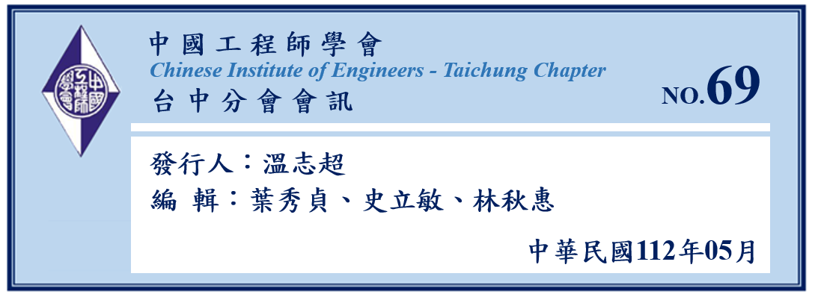

目錄
- 會務動態 2
- 專題報導 7
- 第53屆理監事選舉及112年度會員大會 15
- 其他相關資訊 20

- 會務動態

中國工程師學會(台中分會)第52屆第7次理監事會議記錄
時間：112年3月24日（星期五）；下午14時40分
地點：國立中興大學電機大樓407會議室
- 主席致詞
- 工作報告(略)
- 討論事項
一、召開本分會112年會員大會時間及參訪地點等相關事宜：
說明：112年會員大會預定於5月26日(星期五)召開，當日上午於中興大學辦理會員大會，中午用餐後再搭遊覽車進行下午的工程參訪，有關參訪地點及參加人數是否設定上限，提請討論：
決議：將參訪由水利署第四河川局及雲林縣政府共同打造，榮獲行政院第22屆公共工程金質獎特優獎之「濁水溪出海口生態基地永續工程」及麥寮老街半日遊。
二、本分會112年會員大會議程討論：
說明：112年會員大會議程、擬邀請貴賓、贊助單位(負責人)、團體會員(代表)名單、講者及相關活動議程(如下表)，提請討論：
決議：

中國工程師學會台中分會112年會員大會
活動議程表
時間：112年5月26日(星期五)
時間 | 主題 | 地點 | 主持人
08:30-09:00 | 報到及聯誼交流 | 國立中興大學電機大樓  EE101階梯教室
08:45- | 第53屆理監事選舉投標開始 | 國立中興大學電機大樓  103室
09:00-09:15 | 主席致詞/貴賓介紹 | 國立中興大學電機大樓  EE101階梯教室 | 蔡常務監事 清池
09:15-09:30 | 頒證授獎 | 國立中興大學電機大樓  EE101階梯教室 | 蔡常務監事 清池
09:30-10:10 | 專題演講  『公共工程金質獎特優～濁水溪出海口生態基地永續工程』  主講人:經濟部水利署第四河川局  李友平局長 | 國立中興大學電機大樓  EE101階梯教室 | 蔡常務監事 清池
10:10-10:30 | 會務報告 | 國立中興大學電機大樓  EE101階梯教室 | 蔡常務監事 清池
10:30-11:00 | 臨時動議 | 國立中興大學電機大樓  EE101階梯教室 | 蔡常務監事 清池
10:45 | 第53屆理監事選舉投標截止 | 國立中興大學電機大樓  103室
11:00-13:00 | 餐敘 | 國立中興大學電機大樓  103室
11:00-13:00 | 第53屆理監事選舉開票 | 國立中興大學電機大樓  103室 | 蔡常務監事 清池
13:00 | 大會結束

理監事選舉現場投票、現場開票，選出53屆理監事。

中國工程師學會台中分會112年工程參訪
活動議程表
時間：112年5月26日(星期五)
時間 | 主題 | 地點
13:00-13:10 | 集合出發 | 國立中興大學電機大樓  1樓大門口
13:10-14:25 | 驅車前往濁水溪出海口生態基地 | 濁水溪出海口生態基地
14:25-15:30 | 濁水溪出海口生態基地永續工程參訪  領隊：林秋惠、史立敏 | 濁水溪出海口生態基地
15:30-15:50 | 驅車前往麥寮老街 | 麥寮老街
15:50-17:00 | 麥寮老街參訪  領隊：林秋惠、史立敏 | 麥寮老街
17:00- | 賦歸

三、112年會員大會預算項目及金額討論：
說明：會員大會支出項目包括郵寄大會通知、邀請專家學者演講、保險費、餐費、傑出獎項得獎人及講者獎牌及租用遊覽車資等，總會每年補助分會新臺幣5萬元辦理分會各項活動。不足部分經費來源，提請討論:
決議：將向外界募集資金，以補足經費不足部分。

四、本屆理監事任期於112年6月30日屆滿，下屆理監事候選人員名單提請討論：
說明：下屆理監事候選人由本分會會員具有選舉及被選舉權者，依下列方式產生：
- 徵詢本屆理監事有意願參選者
- 由本屆理監事推薦
- 經由網頁或信件徵詢會員舉薦
提請討論。
決議：同意上述理監事候選人產生方式，惟第1點，本屆理監事除非有表示不願再參選者，按往例，將全數列入理監事參選名單。
五、增訂本分會組織章程第四章-組織中條文，關於無故缺席理、監事會議之理、監事處置方式：
說明：參考總會組織章程第四章-組織第二十七條:本學會理事、監事應親自出席理事、監事會議，不得委託他人代理；連續二次無故缺席者，視同辭職。(總會及分會組織章程詳附件)。本分會組織章程是否增訂上述條文，惟無故缺席次數為二次或幾次，提請討論：
決議：增訂分會組織章程第四章-組織條文，連續四次無故缺席理監事會議者，視同辭職。另章程書寫方式由直式改為橫式。
六、本學會112年「傑出工程教授獎」、「傑出工程師獎」、「優秀青年工程師獎」決選審查結果提報理監事會議通過：
說明：本學會112年各項傑出獎項，於112年3月24日(五)下午2時召開評選會議，經評選委員評選審查結果提報本次理監事會議，通過後為本分會112年「傑出工程教授獎」、「傑出工程師獎」、「優秀青年工程師獎」得獎人。
決議：通過
(一)、112年「傑出工程教授獎」得獎人為:
- 國立雲林科技大學電子工程系林士弘教授
- 國立虎尾科技大學動力機械系楊授印特聘教授兼研發長
(二)、112年「傑出工程師獎」得獎人為:
國家中山科學研究院航空研究所陳永祥工程師
(三)、112年「優秀青年工程師」得獎人:從缺。
- 臨時動議(無)
- 賦歸

第五十二屆第七次理監事聯席會會議照片
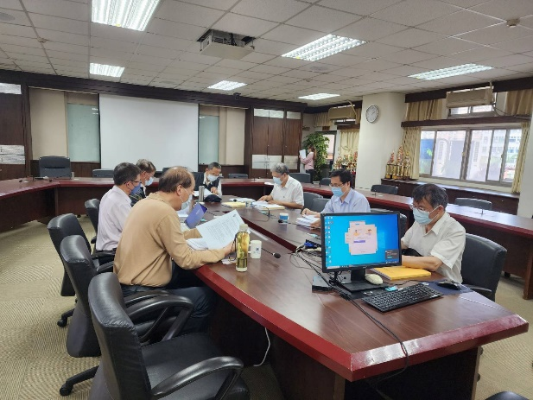 | 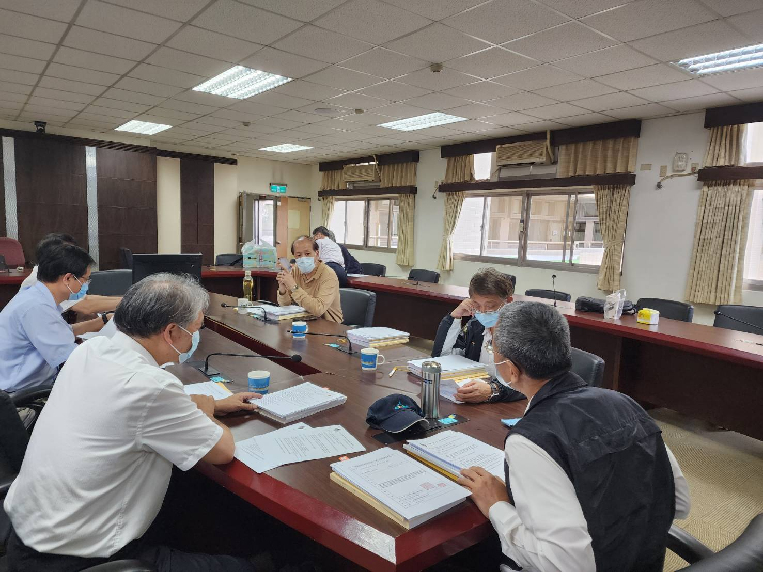
優秀人才評選 | 與會理監事討論

二、專題報導
From Prediction to Response: The Role of AI in Natural Disaster Preparedness
Rajankumar Gohilª, Venkata Subbaiah Munagapatiª, Jet-Chau Wen^{a,b*}
ª Research Centre for Soil & Water Resources and Natural Disaster Prevention (SWAN), National Yunlin University of Science and Technology, Douliu, Yunlin 64002, Taiwan, ROC.
^{b} Department of Safety, Health, and Environmental Engineering, National Yunlin University of Science and Technology, Douliu, Yunlin 64002, Taiwan, ROC.

*Corresponding author:
E-mail address: wenjc@yuntech.edu.tw (Jet-Chau Wen)

Abstract
As natural disasters continue to pose a significant threat to communities worldwide, there is a growing need for innovative solutions to prevent and mitigate their impact. Artificial intelligence (AI) has emerged as a promising tool in disaster management, offering a range of advantages over traditional methods. This article explores the role of AI in preventing natural disasters, including its use in accurate prediction models, real-time monitoring systems, early warning systems, and decision support systems. Additionally, the article examines the potential of AI to analyze big data and identify patterns and trends related to natural disasters, enabling authorities to make informed decisions and allocate resources more effectively. The article also considers how AI can enhance communication and collaboration among disaster management agencies and stakeholders, improving the overall efficiency of disaster response efforts. Overall, this article demonstrates the significant potential of AI in transforming the landscape of natural disaster management and highlights the need for continued research and development in this field.
Keywords: Artificial Intelligence, Natural Disasters, Prevention, Early Warning Systems, Disaster Management

摘要
隨著自然災害持續對全球社區構成重大威脅，人類對於創新解決方案的需求逐漸增加以預防及降低自然災害所產生的影響。人工智慧成為災害管理方面工具乃應運而生，提供了比傳統防災方法較廣泛的優勢。本文探討人工智慧在預防自然災害上所扮演的角色，包括其用於正確預測的方法，即時監控系統，提前預警系統，及決策支援系統方面的運用。此外，本文還探討人工智慧在大數據分析以及識別與自然災害有關的趨勢及模式的潛力，使決策當局能基於具備完整的訊息下作出決策並有效的作資源配置。本文亦考慮災害發生時人工智慧如何加強災害管理機構及利益關係人之間的溝通及合作，提高災害回應工作的整體效率。總體而言，本文說明人工智慧在自然災害管理方面重大改變的潛力及強調相關領域持續研究發展的需要。

Introduction
Natural disasters are a growing concern for communities worldwide, with their devastating impact on human life and infrastructure. According to the United Nations Office for Disaster Risk Reduction, natural disasters have caused over 1.23 million deaths and $2.97 trillion in economic losses globally in the past two decades (CRED, 2020, p. 30). The increasing frequency and intensity of these disasters highlight the need for innovative solutions to prevent and mitigate their impact. Traditional methods of disaster management have been limited in their effectiveness, often relying on reactive measures rather than proactive prevention. However, recent advancements in technology, particularly artificial intelligence (AI), have offered new possibilities for disaster management.
AI has emerged as a powerful tool in preventing natural disasters, providing a range of advantages over traditional methods. AI enables accurate prediction models, real-time monitoring systems, early warning systems, and customized decision support systems, allowing disaster management agencies to take proactive measures to prevent and mitigate the impact of natural disasters. Furthermore, AI can analyze big data to identify patterns and trends related to natural disasters, enabling authorities to make informed decisions and allocate resources more effectively.
Despite these advancements, there remain challenges and limitations in the use of AI in disaster management. The development and implementation of AI technologies require substantial resources and expertise, and issues of data quality, privacy, and ethics must be addressed. Additionally, the potential of AI in disaster management can only be realized through close collaboration and communication among stakeholders, including disaster management agencies, local communities, and technology developers.
This article explores the advantages and challenges of using AI in natural disaster prevention and management. Specifically, it discusses the role of AI in accurate prediction, real-time monitoring, early warning systems, decision support systems, and big data analysis. The article also examines the challenges and limitations of using AI in disaster management and the need for collaborative efforts to develop effective AI-based disaster management systems. Ultimately, this article highlights the potential of AI in transforming the landscape of natural disaster management and the importance of continued research and development in this field.

Advantages of AI in Preventing Natural Disasters
The utilization of artificial intelligence (AI) in preventing natural disasters offers several advantages over conventional methods. According to Kuglitsch et al. (2022), AI can be used to develop accurate prediction models, real-time monitoring systems, early warning systems, and customized decision support systems. Such early warning systems can assist disaster management agencies in issuing evacuation orders and alerts, potentially saving innumerable lives. This capability is particularly important in regions where natural disasters, such as hurricanes, earthquakes, and wildfires, occur frequently and pose a significant threat to life and property. (Martinez, 2019)
Real-time monitoring is another advantage of AI technology. Advanced monitoring systems that employ AI can continuously observe the environmental conditions of a particular location and provide updates in real-time. For instance, sensors and satellite imagery can track alterations in temperature, humidity, wind speed, and precipitation levels, which can aid in the detection and prediction of natural disasters such as wildfires, hurricanes, and floods. (Chiu et al., 2023)
AI technology is also cost-effective compared to traditional methods of disaster prevention and response. Conventional approaches, such as the hiring and training of large teams of human analysts and researchers, can be both costly and time-consuming. In contrast, AI algorithms can analyze vast amounts of data in significantly less time, reducing expenses and increasing efficiency. (S et al., 2021)
Moreover, AI technology can be customized to suit specific geographic locations and natural disaster types. AI algorithms can be trained to analyze data specific to a particular region's topography and weather patterns, resulting in more precise predictions of natural disasters. This can enable disaster management agencies to allocate resources more effectively and respond more efficiently to natural disasters (Tan et al., 2020). Furthermore, Sun et al. (2020) argue that AI can be used to enhance communication and collaboration among disaster management agencies and stakeholders, improving the overall efficiency of disaster response efforts.
Finally, it is noteworthy that AI technology is continuously improving. As more data becomes available and AI algorithms become more advanced, the accuracy of natural disaster prediction and response is expected to improve further. (Chiu et al., 2023)

AI Technologies for Preventing Natural Disasters
AI technologies are emerging as an innovative approach for preventing natural disasters. By analyzing large datasets and providing real-time monitoring, these technologies can assist in predicting and mitigating the adverse effects of natural disasters. The use of AI in natural disaster prevention has significant potential to enhance existing disaster management strategies and improve public safety.
One critical area where AI can have an impact is in predicting natural disasters. AI algorithms can analyze a range of environmental data, including temperature, humidity, wind speed, and precipitation levels, and identify patterns that can indicate the likelihood of a natural disaster. For instance, deep learning algorithms can analyze satellite imagery and other sensor data to detect anomalies and changes in the environment, providing advanced warning of natural disasters such as floods, wildfires, and hurricanes. (Linardos et al., 2022)
Another area where AI can assist in natural disaster prevention is through real-time monitoring. AI algorithms can monitor environmental conditions in real-time, enabling early detection of natural disasters and the timely implementation of appropriate responses. For instance, sensors can detect changes in the water level of rivers and trigger alerts if flooding is imminent. Floods are a significant threat to low-lying areas and can cause extensive damage to property and infrastructure. Additionally, AI technologies can assist in identifying the optimal evacuation routes, thereby enabling people to escape quickly and efficiently. (Sun et al. 2020)
Earthquakes are among the most devastating natural disasters, causing significant damage to infrastructure and loss of human life. AI algorithms can analyze data from seismometers, GPS sensors, and other sources to predict the likelihood and severity of an earthquake. Researchers at Stanford University have developed an AI-based earthquake prediction system called Quake-Catcher Network (QCN) that uses machine learning algorithms to detect seismic activity and issue warnings (Sneed, 2017). Wildfires are a growing concern in many parts of the world, particularly in regions with dry climates. AI technology can monitor forest areas and detect potential fire risks. For example, researchers at the University of California, San Diego, have developed an AI system that uses machine learning algorithms to detect smoke and identify wildfires (Bock, 2023). In the case of hurricanes, AI algorithms can analyze weather data, satellite imagery, and other sources to predict the path and intensity of a hurricane. The National Oceanic and Atmospheric Administration (NOAA) uses AI technology to track hurricanes and issue warnings to affected communities (NOAA, 2023).
Moreover, AI technologies can also assist in disaster response and recovery. For example, AI algorithms can analyze satellite images to assess the extent of the damage caused by a natural disaster and identify the areas that require immediate attention. Additionally, AI-powered robots can be deployed to inaccessible or hazardous areas to conduct search and rescue operations. (Sun et al., 2020)
Furthermore, AI can be used to simulate and model natural disasters, allowing disaster management agencies to plan and prepare more effectively. AI algorithms can generate simulations of natural disasters, enabling officials to test various scenarios and evaluate the effectiveness of different response strategies. This capability can also assist in determining the most effective allocation of resources to mitigate the effects of natural disasters. (Huang et al., 2021)

Ethical Concerns Around AI Bias and Privacy
While AI has the potential to revolutionize the prevention and management of natural disasters, there are also ethical concerns surrounding the use of this technology. One significant concern is the potential for AI bias, which occurs when an algorithm produces results that systematically disadvantage certain groups of people. For example, a study found that an AI-based disaster response system in Florida was less likely to recommend aid to areas with a higher proportion of African American residents (Adam et al., 2022). AI bias can lead to unequal outcomes and exacerbate existing social inequalities.
Another concern is the potential for AI to infringe on individual privacy. AI algorithms rely on large datasets, including personal information, to learn and make predictions. As a result, there is a risk that personal data may be misused, leading to privacy violations. For example, a study found that a natural disaster prediction system based on social media data could be used to identify the locations of individuals and potentially compromise their privacy (Dong et al., 2021).
To address these ethical concerns, researchers and policymakers have proposed various solutions. One approach is to develop transparent and accountable AI systems that can be audited and explainable. This can help identify and mitigate potential biases in AI algorithms (Adam et al., 2022). Additionally, it is essential to ensure that data used in AI systems are collected and used ethically, with appropriate consent and data protection measures in place (Dong et al., 2021).
Overall, while AI has the potential to enhance disaster prevention and management efforts, it is crucial to consider and address ethical concerns around AI bias and privacy to ensure that this technology is used in a responsible and equitable manner.

Conclusion
In recent years, AI technology has shown great promise in preventing and managing natural disasters. By leveraging machine learning algorithms and big data analytics, AI can provide timely and accurate predictions of disasters, improve early warning systems, and aid in disaster response and recovery efforts.
Additionally, AI can facilitate the creation of sophisticated models for predicting and mitigating natural disasters based on large datasets and complex simulations. Chatbots powered by AI language models can provide real-time information to people during natural disasters, answer frequently asked questions, and provide emergency contact information. AI algorithms can analyze social media and news reports to identify disaster-related information and provide situational awareness to authorities. Natural language processing techniques can be used to extract useful information from unstructured data sources like news articles, weather reports, and social media posts.
However, despite the potential of AI, there are also ethical concerns around the use of AI in this context. One significant concern is the potential for AI bias, which can lead to unequal outcomes and exacerbate existing social inequalities. Another concern is the risk of privacy violations due to the use of personal data in AI systems. Policymakers, researchers, and practitioners need to collaborate to address these challenges and explore innovative approaches to harness the full potential of AI in disaster prevention and management.
Despite these challenges, AI has the potential to significantly enhance our ability to prevent and respond to natural disasters. As we continue to develop and refine these technologies, it is essential to prioritize ethical considerations and ensure that AI is used responsibly and equitably. Overall, while there is still much work to be done, the rise of AI in preventing natural disasters offers a glimpse into a future where technology can help us tackle some of the most pressing challenges facing humanity.

References
Adam, H., Balagopalan, A., Alsentzer, E., Christia, F., & Ghassemi, M. (2022). Mitigating the impact of biased artificial intelligence in emergency decision-making. Communications Med, 2(1), 149. https://doi.org/10.1038/s43856-022-00214-4
Bock, S. (2023, May 2). The AI Revolution is Upon Us—And UC San Diego Researchers Are Using it to Inform Climate Action. UC San Diego Today. https://today.ucsd.edu/story/the-ai-revolution-climate-action
Centre for Research on the Epidemiology of Disasters (CRED). (2020). The human cost of disasters: An overview of the last 20 years (2000-2019). United Nations Office for Disaster Risk Reduction (UNDRR). https://www.undrr.org/publication/human-cost-disasters-overview-last-20-years-2000-2019
Chiu, M., Wei, C., Wang, Y., & Kao, M. (2023). Applying unsupervised learning method to develop a regional risk model based on TCFD: A case study in the United States. Journal of Cleaner Production, 400(Complete). https://doi.org/10.1016/j.jclepro.2023.136669
Dong, Z. S., Lingyu, M., Christenson, L., & Fulton, L. (2021). Social media information sharing for natural disaster response. Nat Hazards, 107(2077–2104). https://doi.org/10.1007/s11069-021-04528-9
Huang, D., Wang, S., & Liu, Z. (2021). A systematic review of prediction methods for emergency management. International Journal of Disaster Risk Reduction, 62, 102412. https://doi.org/10.1016/j.ijdrr.2021.102412
Kuglitsch, M., Albayrak, A., Aquino, R., Craddock, A., Edward-Gill, J., Kanwar, R., Koul, A., Ma, J., Marti, A., Menon, M., Pelivan, I., Toreti, A., Venguswamy, R., Ward, T., Xoplaki, E., Rea, A., & Luterbacher, J. (2022, August 5). Artificial Intelligence for Disaster Risk Reduction: Opportunities, Challenges, and Prospects. World Meteorological Organization. https://public.wmo.int/en/resources/bulletin/artificial-intelligence-disaster-risk-reduction-opportunities-challenges-and
Linardos, V., Drakaki, M., Tzionas, P., & Karnavas, Y. L. (2022). Machine Learning in Disaster Management: Recent Developments in Methods and Applications. Machine Learning and Knowledge Extraction, 4(2), 446–473. https://doi.org/10.3390/make4020020
Martinez, V. R. (2019, May 15). Identifying Disaster-related Tweets using NLP. DataDrivenInvestor. https://www.datadriveninvestor.com/2019/05/15/identifying-disaster-related-tweets-using-nlp/
National Oceanic & Atmospheric Administration. (2023, March 9). NOAA satellites help us prepare for severe weather. National Environmental Satellite, Data, and Information Service. https://www.nesdis.noaa.gov/news/noaa-satellites-help-us-prepare-severe-weather
S, S. M., Manjunath, K., & R, K. U. (2021). The Rise of IoT and Big Data Analytics for Disaster Management Systems. In J. Zhao & V. Kumar (Eds.), Handbook of Research on Innovations and Applications of AI, IoT, and Cognitive Technologies (pp. 42-62). IGI Global. https://doi.org/10.4018/978-1-7998-6870-5.ch003
Sneed, A. (2017, February 15). Can Artificial Intelligence Predict Earthquakes? Scientific American. https://www.scientificamerican.com/article/can-artificial-intelligence-predict-earthquakes/
Sun, W., Bocchini, P., & Davison, B. D. (2020). Applications of artificial intelligence for disaster management. Nat Hazards, 103(3), 2631–2689. https://doi.org/10.1007/s11069-020-04124-3
Tan, L., Guo, J., Mohanarajah, S., & Zhou, K. (2020). Can we detect trends in natural disaster management with artificial intelligence? A review of modeling practices. Nat Hazards, 107(3), 2389-2417. https://doi.org/10.1007/s11069-020-04429-3

三、第53屆理監事選舉及112年度會員大會

- 第53屆理監事選舉
第53屆理監事選舉將於112年5月26日 (五)，08:45~10:45於中興大學進行投票作業，投票地點位置圖，請見圖一。相關候選人簡歷及選舉簽到卡已於112年4月27日前寄出，尚未收取到通知之會員，請與分會秘書處聯繫。
來信請寄： limintwh@yuntech.edu.tw，或電話(05)5376915，史小姐。
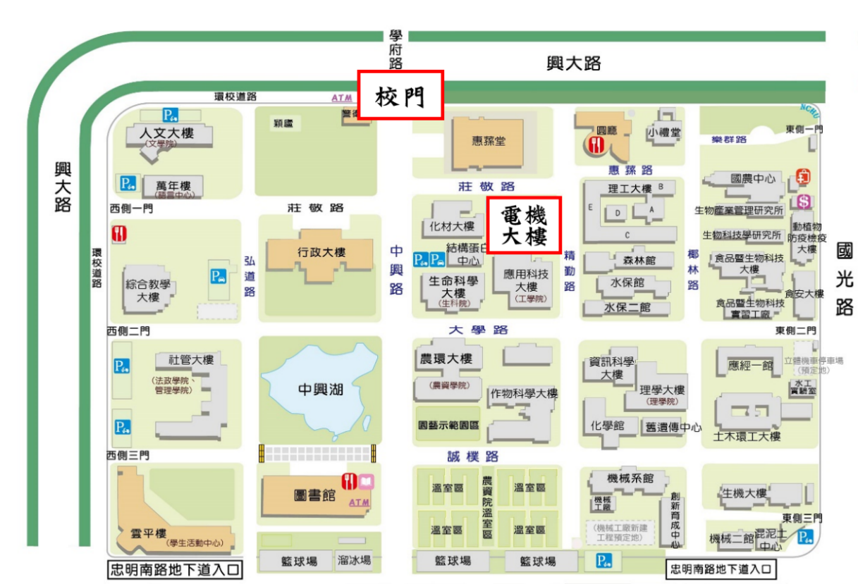
圖一、投票地點位置圖
- 112年度會員大會
為增進會員交誼，達成工程科技、經驗與知識交流，中國工程師學會台中分會「112年會員大會」，擬於112年5月26日 (五)，於中興大學舉行，即日起至112年5月07日(星期日)前，以E-Mail、傳真進行報名。活動議程及報名表如下。
報名資訊：
E-Mail:limintwh@yuntech.edu.tw；傳真: 05-5376916，
郵寄:雲林縣斗六市大學路三段123號國立雲林科技大學水土資源及防災科技研究中心，史小姐收。

中國工程師學會台中分會112年會員大會
活動議程表
時間：112年5月26日(星期五)
時間 | 主題 | 地點 | 主持人
08:30-09:00 | 報到及聯誼交流 | 國立中興大學電機大樓  EE101階梯教室
08:45- | 第53屆理監事選舉投標開始 | 國立中興大學電機大樓  103室
09:00-09:15 | 主席致詞/貴賓介紹 | 國立中興大學電機大樓  EE101階梯教室 | 蔡常務監事 清池
09:15-09:30 | 頒證授獎 | 國立中興大學電機大樓  EE101階梯教室 | 蔡常務監事 清池
09:30-10:10 | 專題演講  『公共工程金質獎特優～濁水溪出海口生態基地永續工程』  主講人:經濟部水利署第四河川局  李友平局長 | 國立中興大學電機大樓  EE101階梯教室 | 蔡常務監事 清池
10:10-10:30 | 會務報告 | 國立中興大學電機大樓  EE101階梯教室 | 蔡常務監事 清池
10:30-11:00 | 臨時動議 | 國立中興大學電機大樓  EE101階梯教室 | 蔡常務監事 清池
10:45 | 第53屆理監事選舉投標截止 | 國立中興大學電機大樓  103室
11:00-13:00 | 餐敘 | 國立中興大學電機大樓  103室
11:00-13:00 | 第53屆理監事選舉開票 | 國立中興大學電機大樓  103室 | 蔡常務監事 清池
13:00 | 大會結束

中國工程師學會台中分會112年工程參訪
活動議程表
時間：112年5月26日(星期五)
時間 | 主題 | 地點
13:00-13:10 | 集合出發 | 國立中興大學電機大樓  1樓大門口
13:10-14:25 | 驅車前往濁水溪出海口生態基地 | 濁水溪出海口生態基地
14:25-15:30 | 濁水溪出海口生態基地永續工程參訪  領隊：林秋惠、史立敏 | 濁水溪出海口生態基地
15:30-15:50 | 驅車前往麥寮老街 | 麥寮老街
15:50-17:00 | 麥寮老街參訪  領隊：林秋惠、史立敏 | 麥寮老街
17:00- | 賦歸

中國工程師學會台中分會112年會員大會報名表
姓 名 | □男 □女 | 會 員 | □ 會員 □ 非會員
 | 出生日期: 年 月 日 | 身分證字號
連絡電話 | 手機： 電話:
E-Mail：
通訊地址
□參加所有行程
□參加部分行程(請勾選)
□會員大會(08:30~11:00)
□午餐(便當) (11:00~13:00) 葷□ 素□
□濁水溪出海口生態基地永續工程參訪與麥寮老街半日遊(13:00~17:00，請勾選
交通方式)
□自行開車前往
□搭乘大會安排遊覽巴士

懇請 貴單位給予公假並協助出席，謝謝。
因本次參訪，需造冊提供參訪人員之基本資料(姓名及身分證字號)，若您攜伴同行，請分別辦理報名程序，以利資料造冊，及保險辦理。

四、其他相關資訊
台中分會網站資訊將持續更新，期望能為台中分會的會員朋友們提供一個分享交流、學習、溝通及傳承的平台，歡迎大家隨時上網瀏覽並提供意見。
為響應環保及節能減碳，中國工程師台中分會會訊，採電子版本發行，刊登於網站上。為便於最新消息及活動資訊傳遞，未來將陸續致電與分會會員進行個人資料補正，或請您填妥下方補正資料，傳送至台中分會第五十一屆祕書處，感謝各位會員朋友的支持與配合。
會員基本資料補正
姓名 |  | 連絡電話
服務單位 |  | 職稱
E-mail
※歡迎使用 Email 回傳至信箱：globalwcc307@gmail.com，謝謝！

會訊徵稿
本會訊歡迎會員投稿，若有資料或意見提供，請與本分會秘書處聯絡，來信請寄： globalwcc307@gmail.com，葉小姐。

